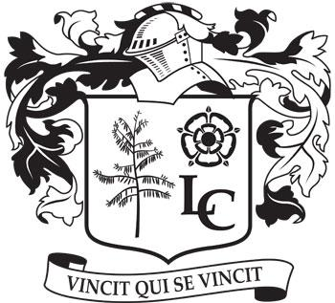
Langwith College Student Association

Date: 24/02/20
Time: 1900
Location: Corner Room

Apologies: Cal, Luise, Patrick, Ash, Gemma, Moh, Annabelle
Absent: Owen, Scott

Minutes

Jonny started the meeting by mentioning the fun run for the langwith development award - James and Vanburgh also interested in the event - make it a competition.

James announced that STYC and STYM applications are in the works.

Business and Communications

Each term spending will be published - send expenditure in before next weekend

Merchandise
Introduced Annabel’s new merch ideas

Sponsorship
-------

RAG
There is a meeting on Wednesday

Events
Summer formal
We are going to view the Principle and the Hilton this week and pick a date.
*Netball want theirs at the Principle
Idea of drinks tokens - money behind the bar

*Fed back on the Leeds Bar Crawl*

Freshers week
Have to start thinking about events

St Patrick’s Day
St Paddys day bar crawl idea with other colleges
May not go ahead with other colleges but we will do it regardless
HES East festival
Replace summer fete
Alpacas

Founding Frenemies
Bar crawl idea
Birthday weekend with Derwent
Kathryn made merch

Committee social
March 8th

Sports

Basketball courts on east are getting refurbished but will still be a recreational space

Varsity
This weekend
Plan to make a breakfast for teams to grab before heading to west

Charity sports day
Week 2 of Summer term
1 day thing (stupid sports) or a 2 day event (silly and sporty) - overall preference on 1 day event due to roses and exams
Money towards it from the college - food vans
RAG event

Langwith sports awards
formal or informal?
work with sports day
present awards on saturday and celebrate on the sunday
win a drinks token

Wellbeing

Head STYC opportunity opened to the committee
STYC and STYM open to committee too

BAME and international
Movie night this Friday at 8pm
Any one can come

LGBTQ
---------------

Disability and Access
-----------------

Environment and Ethics
Adoptive tuesdays start tomorrow

