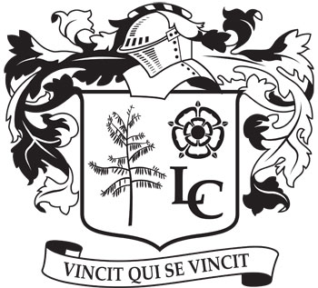
Langwith College Student Association

Date: 05.06.18
Time: 1900
Location: Corner Room

Present: George R, Rohanna, Elisa, Jonathan, Rohail, Samantha, Katie, Naomi, Ose, Nasreen, Emma, Charlotte B, Sasha, Franki, Nathan, Laura, Julia, Ruth, Mariya, Oliver.
Apologies: Charlotte D, Sydney, Rose, Cal, George W, Georgia, Ailsa.
Absent: Naomi, Anastasia.

Minutes

Business and Communications
Merchandise
College Merchandise to be sold during arrivals day, possibly near the DJ to draw people in.
ACTION: Officers to make sure this is organized.

Sponsorship
We have now received sponsorship from Flares and Popworld therefore we need to keep these on the route for our bar crawl in freshers week.
ACTION: See above.

Communications
We need to organize a handbook where we establish the role of the LCSA, STYMs and STYCs. Get all our social media out and get everyone to follow it there and then.
ACTION: This to be organized over the summer before we come back in September.

Events

Freshers’ Week
Friday Night Campus Bar Crawl means the Glasshouse will need to be decorated. Events officers to liaise with the Glasshouse concerning the theme and budget for decorations. We will have a rota for responsible people on each freshers night so that some exec and wellbeing members can have some nights off.
ACTION: Sydney and officers to finalise budget and theme for the Glasshouse and then get the decorations.

Bilsland Bar Crawl
Events officers to organize a Bilsland Bar Crawl for Autumn Term week 8.
ACTION: See above.

Activities
Activities Fair
Jonathan to organize all of the sports captains to be at the fair to get people to sign up to college sport.
ACTION: Jonathan and sports officers to make sure the captains know about it.

Volunteering
The Big Green Clean to be set up and run during international arrivals day.
ACTION: Franki and Georgia to make sure this is organized.

Wellbeing

Free Food
ACTION: See above.

BAME
BAME officers to discuss their plans for a mixer during fresher’s week further with Constantine and finalise the budget to give to George or Charlotte D.
ACTION: Officers to get on top of this and pass on the budget.

Arrivals Day-Freshers’ Week
Food will be provided for Head STYCs during arrivals day because they will have to be at Langwith all day. STYCs will be split in half, with one half helping out in the morning and second for the afternoon. STYMs to arrive when their blocks move in to introduce themselves to the freshers’.
ACTION: Logistics of the day to be finalized by Elisa and George.

Orientation Day
During this talk we will establish the role of the LCSA and Head STYCs. Also briefly mention the upcoming elections. We need to make sure this does not come across cheesey as it has done in recent years and get the STYMs to also speak during this talk.
ACTION: Powerpoint and arrivals information to be organised ahead of Fresher’s Week.

International
A survey is going out soon to all international students that will hopefully give us more insight into how to improve communications and events for the international students in Langwith. Get the information out to international students before the arrivals day.
ACTION: International officers to feedback to the committee when they get the results of the survey.

